May 2022
Llandow Ward Community Council Report
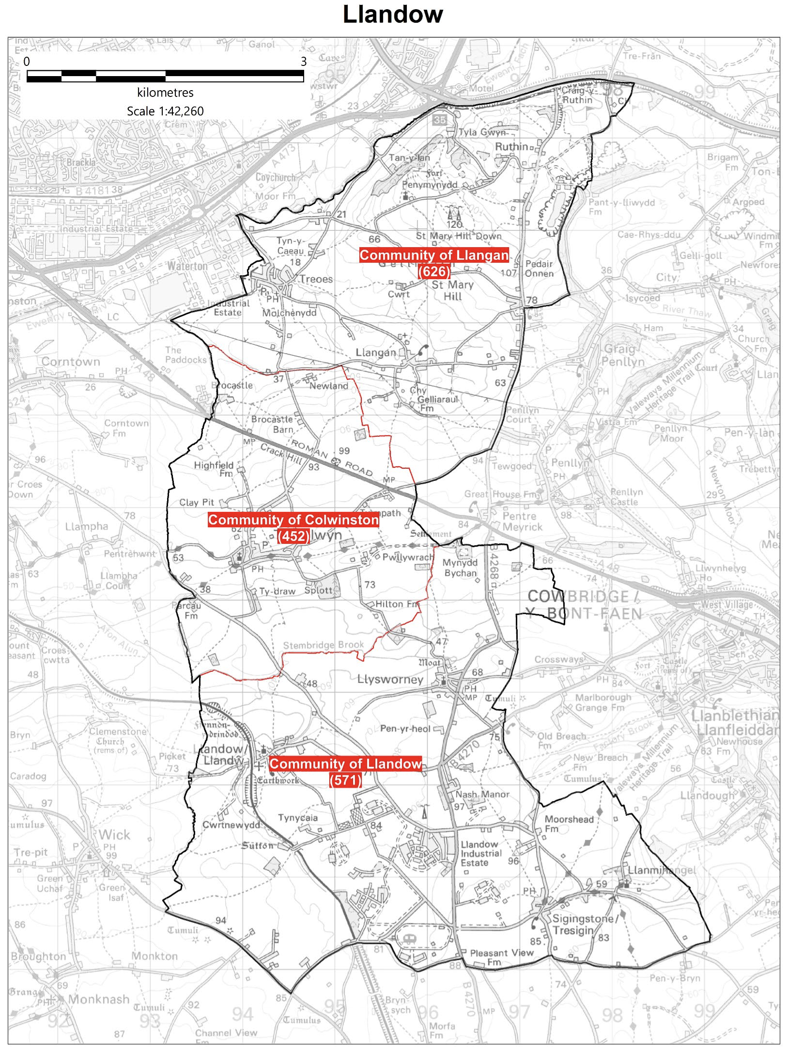

Cllr. Christine Cave email: cacave@valeofglamorgan.gov.uk
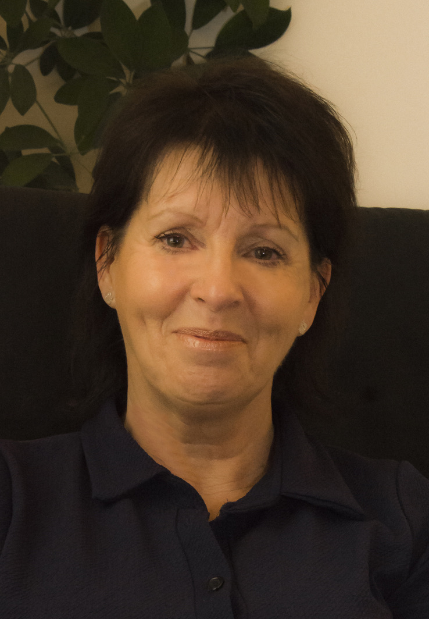
Date: October/November 2022- Report to the Community Councils (CC) in the Llandow Ward: Colwinston; Llandow/, Llysworney, Sigingstone, Sutton and Llangan/Treoes and St Mary Hill.

Vale of Glamorgan Council (VoGC) meetings:

Vale of Glamorgan Full Council meeting date for 2022/23:-

9th November 2022 (special council meeting)
5th December, 2022
6th March, 2023
24th April, 2023.

Members of the Cabinet:
Councillor L. Burnett (Executive Leader and Cabinet Member for Performance and Resources)
Councillor B.E. Brooks (Deputy Leader and Cabinet Member for Sustainable Places)
Councillor R.M. Birch (Cabinet Member for Education, Arts and the Welsh Language)
Councillor M.R. Wilson (Cabinet Member for Neighbourhood and Building Services)
Councillor M.R. Wilkinson (Cabinet Member for Public Sector Housing and Tenant Engagement)
Councillor E. Williams (Cabinet Member for Social Care and Health)
Councillor S. Sivagnanam (Cabinet Member for Community Engagement, Equalities and Regulatory Services)
Councillor G. John (Cabinet Member for Leisure, Sport and Well-being)

Cabinet meeting Minutes of a hybrid meeting held on:

3rd November 2022
AGENDA
1. Apologies for absence.
2. Minutes of the Meetings held on 20th October, 2022.
References –
4. Welsh Language Standards Annual Monitoring Report 2021-22 – Corporate Performance and Resources Scrutiny Committee, 12th October, 2022.
5. Vale of Glamorgan Public Services Board Annual Report 2020-21 – Corporate Performance and Resources Scrutiny Committee, 12th October, 2022.
6. Final Draft Vale of Glamorgan Council Annual Self-Assessment Report 2021/22 – Governance and Audit Committee: 24th October, 2022.
Report of Meeting –
7. Shared Regulatory Services, 27th September, 2022.
Reports of the Executive Leader and Cabinet Member for Performance and Resources –
8. Capital Monitoring for the Period 1st April to 30th September, 2022.
9. A Fairer Tax Consultation.
Report of the Cabinet Member for Education, Arts and the Welsh Language –
10. Proposal to Transfer Specialist Resource Base at Llandough Primary to Ysgol Y Ddraig.
Report of the Cabinet Member for Neighbourhood and Building Services –
11. Award of Engineering Call-off Contract for Direct Labour and Plant 2022-2024.
Report of the Cabinet Member for Social Care and Health –
12. Consultation on Proposals for Primary Legislation in Relation to Children’s Social Care, Continuing Health Care, Mandatory Reporting and Regulation and Inspection.

6th October 2022
AGENDA

1. Apologies for absence.
2. [View Minute] last meeting
Reference –
3. Applications for Appointment for Current Local Authority Governors’ Vacancies – Local Authority Governors Advisory Panel, 5thOctober, 2022.
[View Minute]
Report of Meeting –
4. Cardiff Capital Region Regional Cabinet – 26th September, 2022.
[View Minute]
Reports of the Executive Leader and Cabinet Member for Performance and Resources –
5. Cabinet Quarterly Work Programmes – July to September 2022 and October to December 2022.
[View Minute]
6. Revenue Monitoring for the Period 1st April to 31st August, 2022.
[View Minute]
7. Capital Monitoring for the Period 1st April to 31st August, 2022.
[View Minute]
8. Draft Capital Strategy 2023/24 and Initial Capital Programme Proposals 2023/24 to 2027/28. [View Supplemental Appendix 3]
[View Minute]
9. Financial Strategy 2022/23 and Medium Term Financial Plan Refresh.
[View Minute]
Report of the Cabinet Member for Social Care and Health –
10. Cardiff and Vale of Glamorgan Market Stability Report 2022.
[View Minute]

Reports of the Cabinet Member for Community Engagement, Equalities and Regulatory Services –
11. Vale of Glamorgan Local Development Plan 2011-2026: Annual Monitoring Report 2021/2022.
[View Minute]
12. Dwr Cymru Welsh Water Consultation on the Drainage and Wastewater Management Plan (DWMP).
[View Minute]

Current Consultations Vale of Glamorgan Council
The Vale of Glamorgan Council current consultations section includes the work of the Council as well as other public organisations that operate in the Vale.
Your Penarth Esplanade - A thriving seafront for all
More than £500,000 has been invested in Penarth Pier Pavilion and the Esplanade in the last two years. The Vale of Glamorgan Council is now speaking to local residents, businesses, and community groups about how to further improve Penarth seafront and the surrounding area.
Your Penarth Esplanade
Draft Recycling and Waste Strategy 2022-2032
Recycling and Waste Management is an essential service provided by the Council. It affects all of our residents, as well as local businesses and visitors to the county. This strategy will contribute to all of the organisation's objectives and the seven national well-being goals.
Draft Recycling and Waste Strategy
Help us decide our priorities for 2023/24
We're consulting on what we need to focus on for the future. To do this, we need to look at what we achieved and what we could have done differently. You can let us know whether you agree with our progress, commitments and objectives by completing our short survey.
Our Priorities for 2023/24 consultation
Review of statues, monuments, street and building names and suggestions for future recognition and commemoration.
The Council is proactively reviewing all statues and commemorations in the Vale of Glamorgan. This work will ensure statues and commemorations on public land, as well as the names of streets and buildings are representative of local people’s values and those of a modern, inclusive Council. If you have seen a commemoration that you think should be reviewed to ensure it is appropriate, please complete our online form. Please ensure you include the location and reason for review.
Recognition and Commemoration
New Housing Development - Requirements for School Places
There are a number of new housing developments in the Vale. We are asking residents who are moving to new housing developments to let us know their requirements for school places. Please read the letter below and respond to the online survey.

Local Matters
- Rural Road Traffic issues/road safety: identification of local road safety hotspots to inform way forward – Consultation with council and CC’s ongoing.
- Colwinston – Coffin stile –- ongoing – I have written again to the VoG’s conservation officer.
- Colwinston – Heol CAe Pwll adoption raised with Miles Punter – response provided by Miles Punter – ongoing.
- Colwinston – Active travel plan awaiting response from legal team within the council following support from the CC.
- Colwinston – Junction on Church Lane and The Vines Colwinston road safety issue raised with VoG
- Colwinston – Twmpath Track Obstruction - ongoing
- Colwinston – Various matters raised in respect to St. David’s Church in Wales School.
- Colwinston – purchasing of flag for Remembrance Sunday.
- Colwinston - Parliamentary Boundary Review – ongoing.
- Llandow – weight restriction signage and road layout Nash Junction/Llysworney speeding issues – ongoing. Speedwatch issues has seen Alun Cairns MP write on several occasions now directly to the Chief Constable of South Wales.
- Llandow – Llysworney Community Association meeting to discuss planning application for 10 flats – ongoing.
- Llandow – Sigingstone pre planning consultation, matters raised with local AM and others – application will come to the planning committee – new planning application made – ongoing.
- Llandow – Sigingstone Environmental Health officer contacted in relation to the activities at the go-kart track – Llandow CC monitoring the situation – ongoing.
- Llangan – Parc Newydd - ongoing
- Llangan – Solar farm pre planning consultation Troeos – ongoing
- Various housing and home care issued raised with respective officers for the Western Vale – ongoing.

Scheduled Meetings for November 2022 - All Meetings commence at 6.00 p.m. and be held virtually unless otherwise stated
Council | 9 Nov (Special) | Early Retirement/Redundancy (4.00 p.m.) | 24 Nov
Annual Meeting |  | Licensing - Public Protection  (10.00 a.m.) | 8 Nov
Cabinet (2.00 p.m.)  [View Live Stream - 3 November] | 14 Nov;  28 Nov  3 Nov;  17 Nov | Licensing - Statutory
Scrutiny (Corporate Performance and Resources) | 16 Nov | Licensing Sub (10.00 a.m.)
Scrutiny (Environment and Regeneration) | 15 Nov | Planning (4.00 p.m.) | 23 Nov
Scrutiny (Healthy Living and Social Care)  (5.00 p.m.)  [View Live Stream - 8 November] | 8 Nov | Public Rights of Way | 3 Nov
Scrutiny (Homes and Safe Communities)  [View Live Stream - 7 November] | 9 Nov  7 Nov | Senior Management Appointment (4.00 p.m.)  [View Live Stream - 3 Nov] | 3 Nov
Scrutiny (Learning and Culture) (5.00 p.m.) | 10 Nov | Standards (10.00 a.m.) | 24 Nov
Appeals |  | Trust
Goverance and Audit |  | Vale of Glamorgan Local Access Forum
Community Liaison |  | Voluntary Sector Joint Liaison
Democratic Services  (4.00 p.m.) | 14 Nov  21 Nov | Welsh Church Act Estate
Investigating |  | Shared Regulatory Services Joint Committee

